**Net 1060 Introduction to Networks Lab: # 2.7.6**

**Name: Andrew Koenig**

**Follow the instructions down below for the lab itself. For this lab, all answers need to be in blue font. For the questions right below, answer in complete sentences. Ensure you paste the screen shot of your score page at the bottom of the document. Even if this does not let you see your grade, still take a screen shot of the score page showing congratulations “your name” you have completed the exercise is pasted at the bottom of this document. You will then need to upload both this word document and your packet tracer file to the assignments link within Netacad. Let the instructor know if you have any questions.**

***Lab Analysis Report***

1. Using complete sentences summarize work you completed during the lab.

I did basic config on a few switches and some ip config on all the devices.

2. Using complete sentences describe what you learned from the lab. Hint; look at the lab objectives listed at the top of the lab section.

I learned how to configure and ping the ip addresses of a few different devices.

***Problems Encountered***

1. Using complete sentences describe any problem(s) experienced during lab.

Packet tracer didn’t recognize the passwords

2. Using complete sentences describe how you solved your problem(s).

I was not able to.

3. Using complete sentences explain if you needed any assistance with the lab; then list what you learned from that assistance. None needed

Packet Tracer - Implement Basic Connectivity

# Addressing Table

|  |  |  |  |
| --- | --- | --- | --- |
| Device | Interface | IP Address | Subnet Mask |
| S1 | VLAN 1 | 192.168.1.253 | 255.255.255.0 |
| S2 | VLAN 1 | 192.168.1.254 | 255.255.255.0 |
| PC1 | NIC | 192.168.1.1 | 255.255.255.0 |
| PC2 | NIC | 192.168.1.2 | 255.255.255.0 |

# Objectives

**Part 1: Perform a Basic Configuration on S1 and S2**

**Part 2: Configure the PCs**

**Part 3: Configure the Switch Management Interface**

# Background

In this activity, you will first create a basic switch configuration. Then, you will implement basic connectivity by configuring IP addressing on switches and PCs. When the IP addressing configuration is complete, you will use various **show** commands to verify the configuration and use the **ping** command to verify basic connectivity between devices.

# Instructions

## Perform a Basic Configuration on S1 and S2

Complete the following steps on S1 and S2.

### Configure S1 with a hostname.

* + - 1. Click S1 and then click the CLI tab.
      2. Enter the correct command to configure the hostname as S1.

### Configure the console and encrypted privileged EXEC mode passwords.

* + - 1. Use **cisco** for the console password.
      2. Use **class** for the privileged EXEC mode password.

### Verify the password configurations for S1.

#### Question:

How can you verify that both passwords were configured correctly?

Show running-config will show themType your answers here.

### Configure an MOTD banner.

Use an appropriate banner text to warn unauthorized access. The following text is an example:

**Authorized access only. Violators will be prosecuted to the full extent of the law.**

### Save the configuration file to NVRAM.

#### Question:

Which command do you issue to accomplish this step?

Copy running-config startup-configType your answers here.

### Repeat Steps 1 to 5 for S2.

## Configure the PCs

Configure PC1 and PC2 with IP addresses.

### Configure both PCs with IP addresses.

* + - 1. Click PC1 and then click the Desktop tab.
      2. Click IP Configuration. In the Addressing Table above, you can see that the IP address for PC1 is 192.168.1.1 and the subnet mask is 255.255.255.0. Enter this information for PC1 in the IP Configuration window.
      3. Repeat steps 1a and 1b for PC2.

### Test connectivity to switches.

* + - 1. Click PC1. Close the IP Configuration window if it is still open. In the Desktop tab, click Command Prompt.
      2. Type the **ping** command and the IP address for S1 and press Enter.

Packet Tracer PC Command Line 1.0

PC> **ping 192.168.1.253**

#### Question:

Were you successful? Explain.

No, the request timed out your answers here.

## Configure the Switch Management Interface

Configure S1 and S2 with an IP address.

### Configure S1 with an IP address.

Switches can be used as plug-and-play devices. This means that they do not need to be configured for them to work. Switches forward information from one port to another based on MAC addresses.

#### Question:

If this is the case, why would we configure it with an IP address?

Type So that it has an address instead of just putting info down a different line.your answers here.

Use the following commands to configure S1 with an IP address.

S1# **configure terminal**

Enter configuration commands, one per line. End with CNTL/Z.

S1(config)# **interface vlan 1**

S1(config-if)# **ip address 192.168.1.253 255.255.255.0**

S1(config-if)# **no shutdown**

%LINEPROTO-5-UPDOWN: Line protocol on Interface Vlan1, changed state to up

S1(config-if)#

S1(config-if)# **exit**

S1#

#### Question:

Why do you enter the **no shutdown** command?

This command brings the device onlineType your answers here.

### Configure S2 with an IP address.

Use the information in the Addressing Table to configure S2 with an IP address.

### Verify the IP address configuration on S1 and S2.

Use the **show ip interface brief** command to display the IP address and status of all the switch ports and interfaces. You can also use the **show running-config** command.

### Save configurations for S1 and S2 to NVRAM.

#### Question:

Which command is used to save the configuration file in RAM to NVRAM?

Copy run start your answers here.

### Verify network connectivity.

Network connectivity can be verified using the **ping** command. It is very important that connectivity exists throughout the network. Corrective action must be taken if there is a failure. Ping S1 and S2 from PC1 and PC2.

* + - 1. Click PC1 and then click the Desktop tab.
      2. Click Command Prompt.
      3. Ping the IP address for PC2.
      4. Ping the IP address for S1.
      5. Ping the IP address for S2.

**Note**: You can also use the **ping** command on the switch CLI and on PC2.

All pings should be successful. If your first ping result is 80%, try again. It should now be 100%. You will learn why a ping may sometimes fail the first time later in your studies. If you are unable to ping any of the devices, recheck your configuration for errors.

End of Document

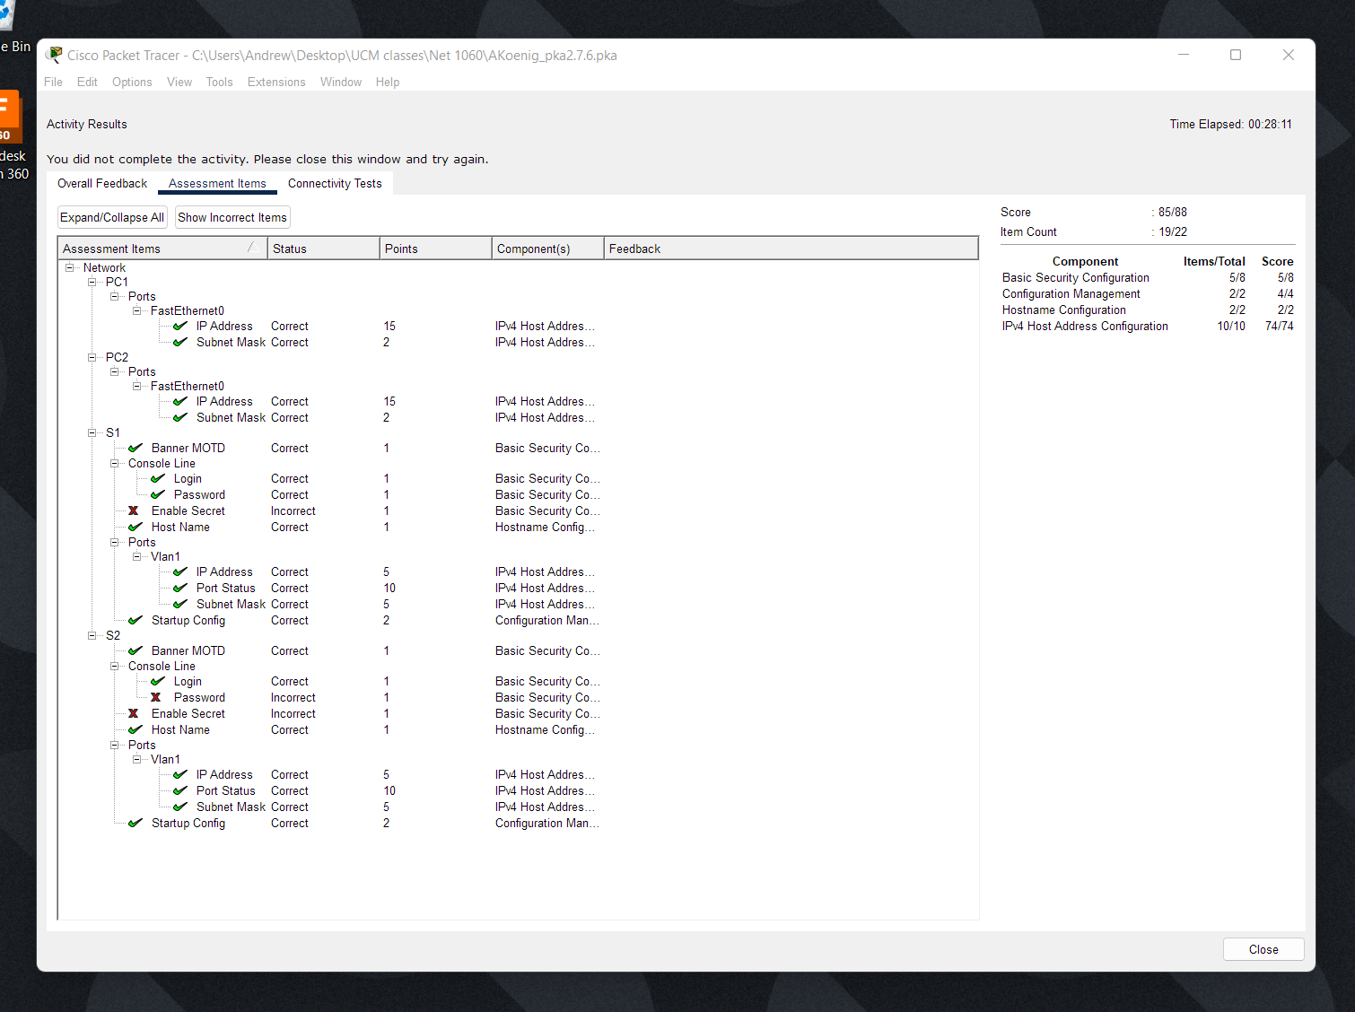

It refused to accept my passwords for privileged exec mode on both, no idea why